**Story board designs concepts:**

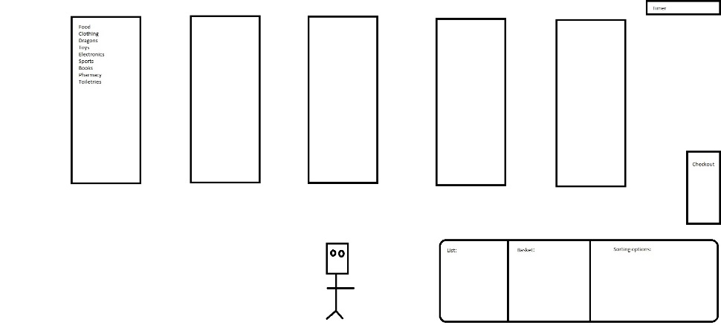

In the first initial design of the game we decided to have clickable aisles that would change to a different screen with different items populating the shelves.

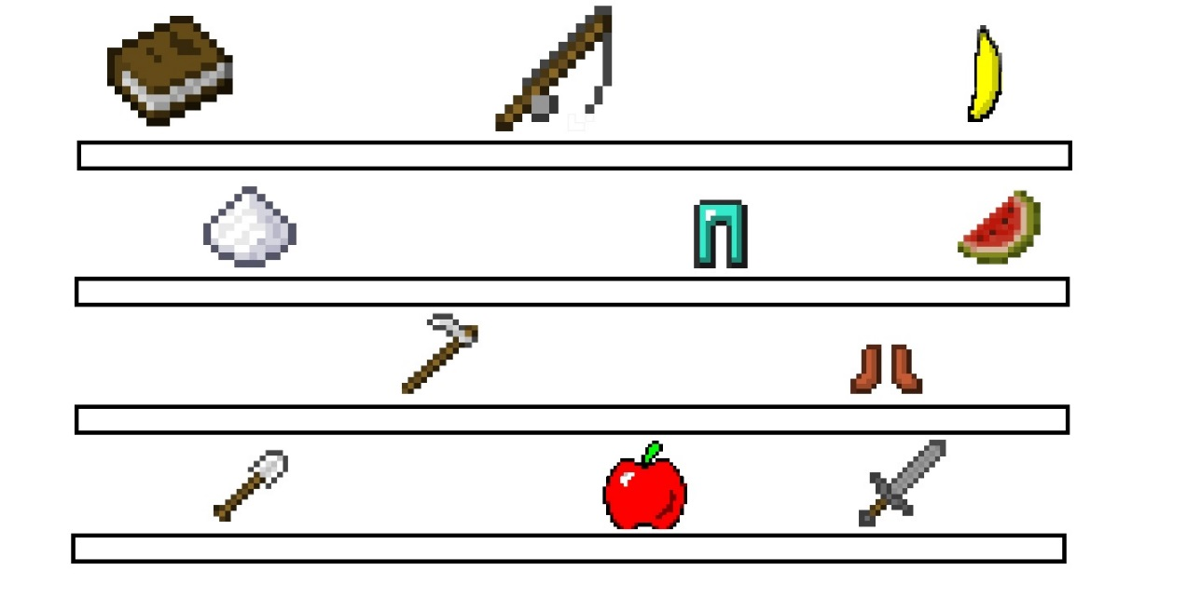

The program would then display the correct screen which displays items and the user would be able to click on the correct on and it would automatically at to the basket.

The overall design concept was the later changed to a maze like game which spawned different items on the map and then the user would be able to move their in game character model on the items and they would then collect in the list.

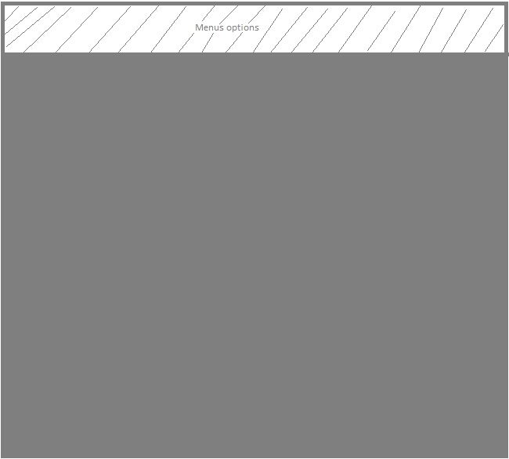

Later we then drafted up a drawn representation of what the first menus screen would contain.

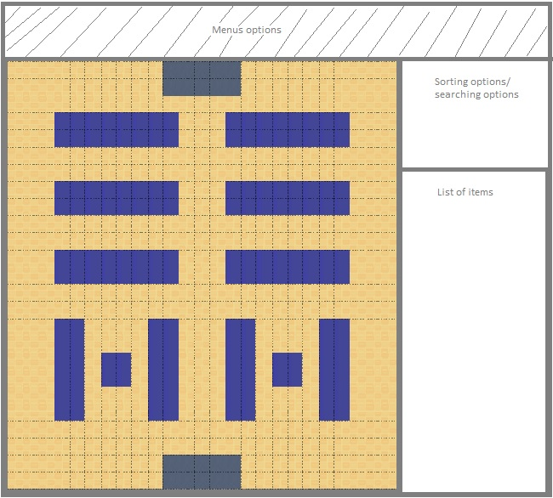

The enitre game screen wil then be kept on one singular window with all of the required infromation displayed on the side of the map; allowing you to access sorting methods.